C. Virginia Fields

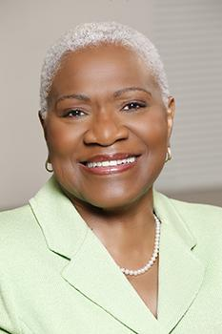
At age 17, C. Virginia Fields took part in the Birmingham Children’s Crusade, where she was arrested and spent a week in jail. She also was also one of the 250,000 people involved in the 1963 March on Washington for Jobs and Freedom. She was active in the Civil Rights Movement from an early age, and eventually went on to become a New York City Council Member, President of Manhattan Borough, and a 2005 New York City mayoral candidate. Although she lost to incumbent Mayor Bloomberg, she was the first African American woman to run for Mayor of New York City. She received her B.A. in Sociology from Knoxville College in Tennessee and her Master of Social Work from Indiana University in 1969. After finishing school, Fields moved to New York and pursued a career in social work before entering the political sphere in 1981. In addition to her active political career, Fields was appointed as president and CEO of The National Black Leadership Commission on AIDS in 2008, and three years later was appointed by Governor Paterson to serve on the U.S. Department of Health and Human Services’ Region II Health Equity Council.

