Rev. Martin Luther King Jr.

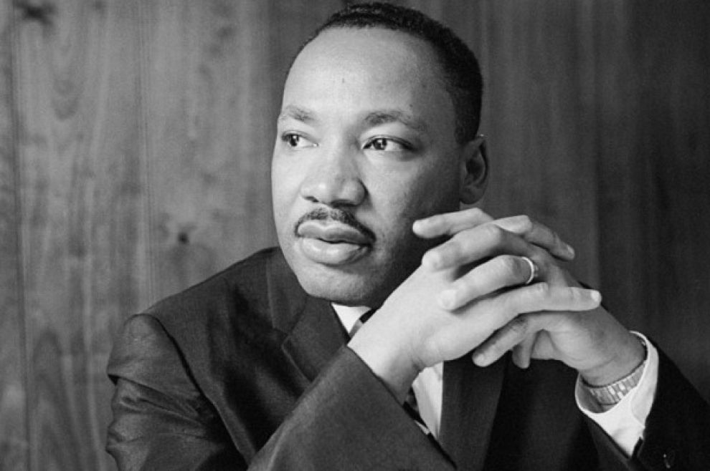
Perhaps the most well-known figure of the modern Civil Rights Movement, Dr. Martin Luther King, Jr. was a fierce advocate for desegregation and racial equality in the U.S. Dr. King served as a member of the executive committee of the National Association for the Advancement of Colored People and the President of the Southern Christian Leadership Conference.

Between 1957 and 1968, King traveled over six million miles and gave over 2,500 speeches advocating for civil rights. Throughout his life, King was arrested upwards of 20 times, his home was bombed, and he was subjected to personal abuse. Dr. King was one of the leaders and organizers of the Birmingham Campaign of 1963. During the Birmingham Campaign, King was arrested and penned his “Letter from a Birmingham Jail,” which caught national attention along with the disturbing images of the brutality against the peaceful marchers in Birmingham. After the Birmingham campaign, he went on to direct the 250,000-person March on Washington, D.C. where he delivered his “I Have a Dream” speech, spoke with President Kennedy, campaigned for President Johnson, and was recognized as Time Magazine’s Man of the Year in 1963. At the age of thirty-five, King became the youngest man to receive a Nobel Peace Prize, and when notified of his selection, declared that he would return the prize money of $54,123 to the furtherance of the Civil Rights Movement. On April 4, 1968, Dr. King was assassinated while standing on the balcony of his motel in Memphis, Tennessee.

