Governor George C. Wallace

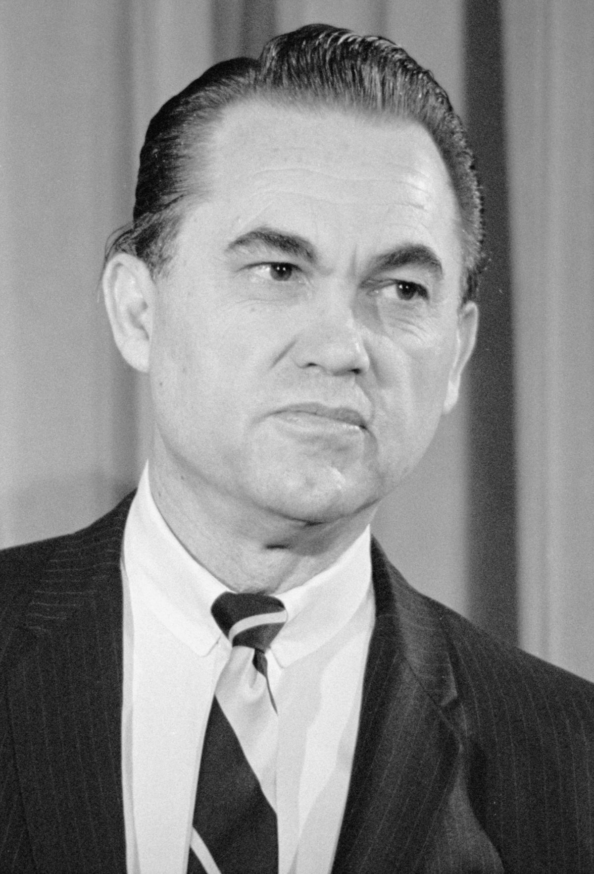
George C. Wallace served as Governor of Alabama four times between 1962 and 1982. Wallace ran on an anti-integration, pro state’s rights platform, which won him support from the Ku Klux Klan. His segregationist stance can best be described by the conclusion of his 1962 inaugural address: “Segregation now, segregation tomorrow, segregation forever!”

Wallace was governor during the Birmingham Children’s Crusade and the larger Birmingham Campaign. He supported the use of violence- including the practice of unleashing police dogs and firehoses- by police and public safety officials to deter the young protesters. In 1963, Wallace also led a “stand-in at the schoolhouse door” to stop two Black students from enrolling at the University of Alabama. Wallace’s opposition was so fierce, that the National Guard was sent to Alabama to intervene and allow the students to enroll. Governor Wallace ran for President three times and continued to oppose integration throughout the remainder of his first two terms as governor. Later in life, Governor Wallace attempted to alter his image as a staunch segregationist and issued a handful of public apologies and claimed that his words had been misconstrued.

